Student name: Belgibayeva Karakat

Professor Name: Azamat Serek

Subject Name: Data Analysis

Date: 10 September 2023

Data analysis project

Description of the data frame names: df_por is the dataset of the students who took Portuguese and the df_mat is the students who took mathematics. The merged dataset of df_por and df_mat is named as both.

**Task 1: The most frequent age in the dataset of the students who took Portuguese is 17 and the least frequent age in the dataset is 22.**

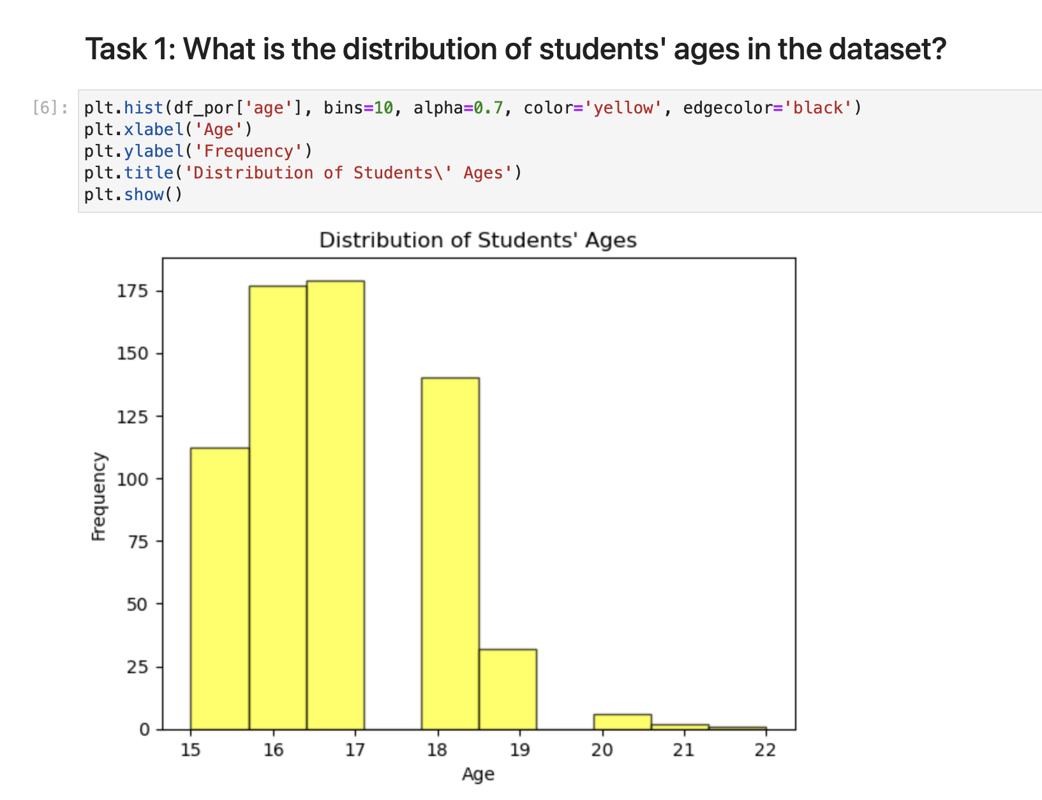

**Task 2: GP has 423 students out of 649, MS school has 226 students out of 649.**

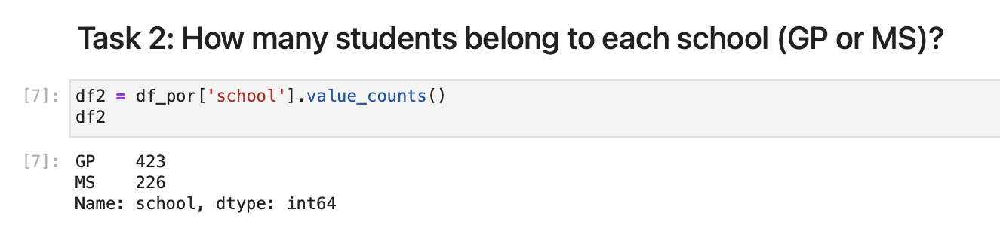

**Task 3: The gender distribution of the dataset df_por is: Female students - 383 out of 649, Male students - 266 out of 649 total number of students. Below is the visual representation of the distribution in the barplot.**

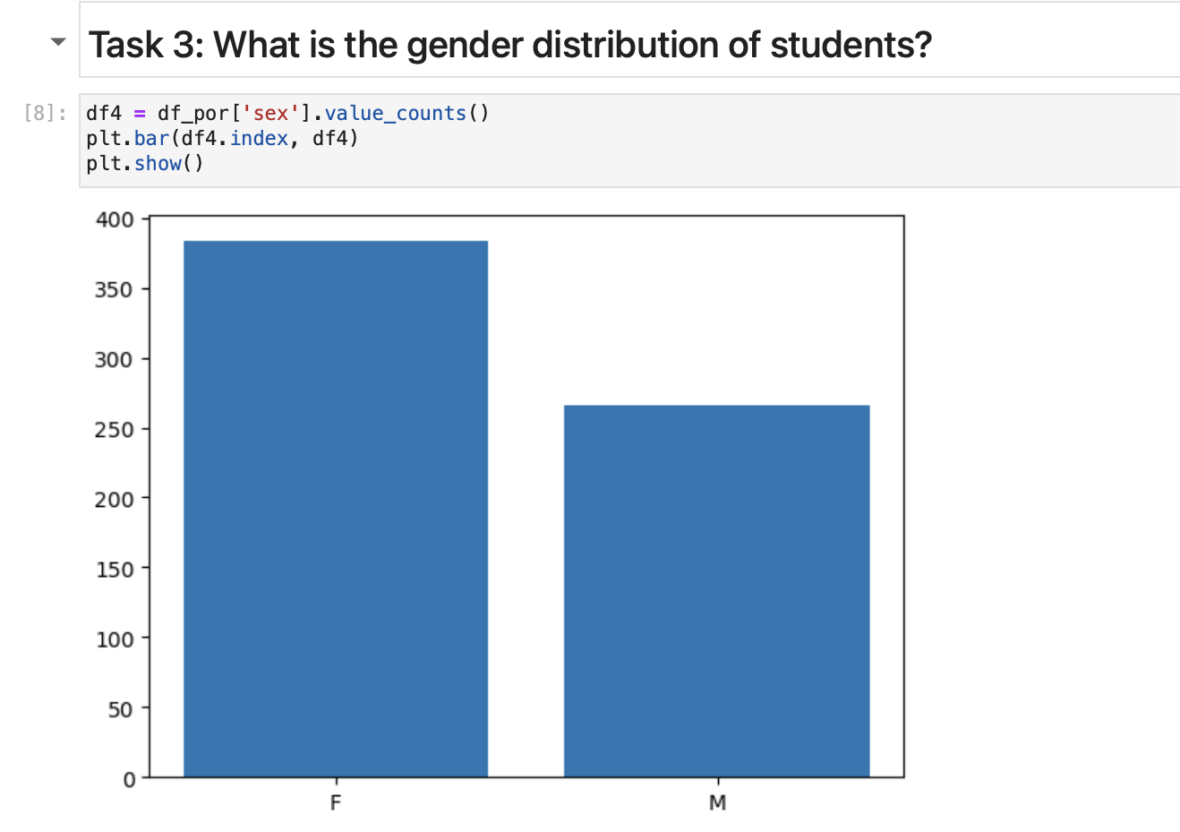

**Task 4: The mode of travel time of students from home to school is 1 hour (approximately 375 students). The least frequent travel time is 4 hours (approximately 20 students).**

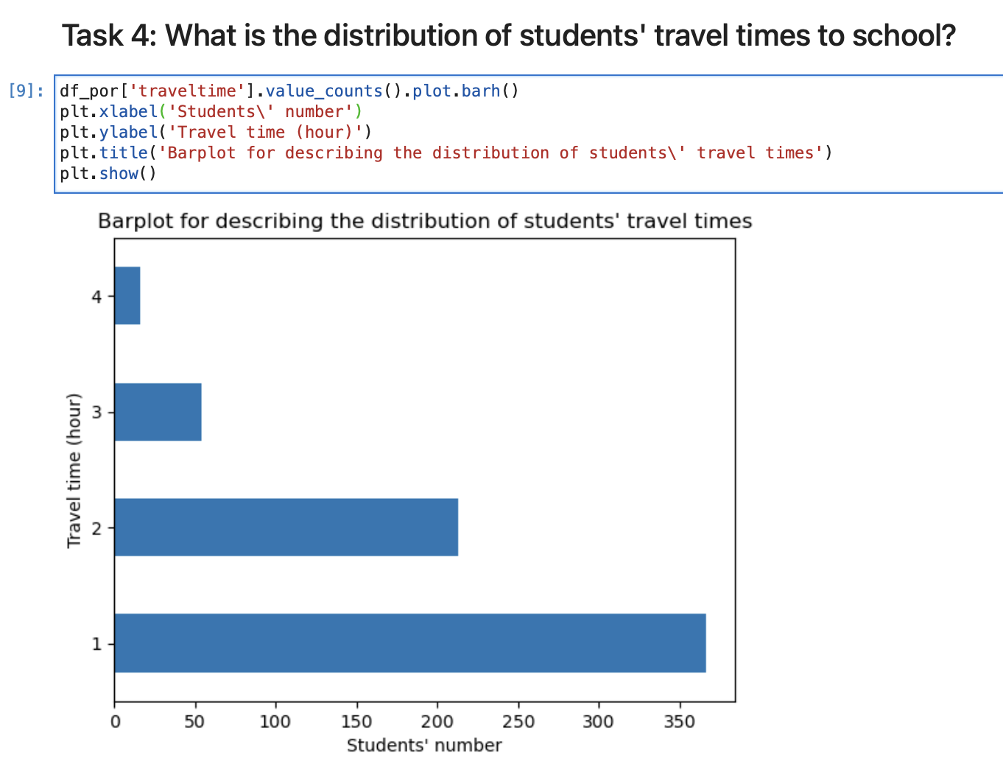

**Task 5:** **In this cross tabulation is shown the study time of the student who got the highest score on G1 and it is 3 hours. The student who got 0 on G1 And his study time is 3 hours. Thus, we can see that the correlation between study time and the score is low.**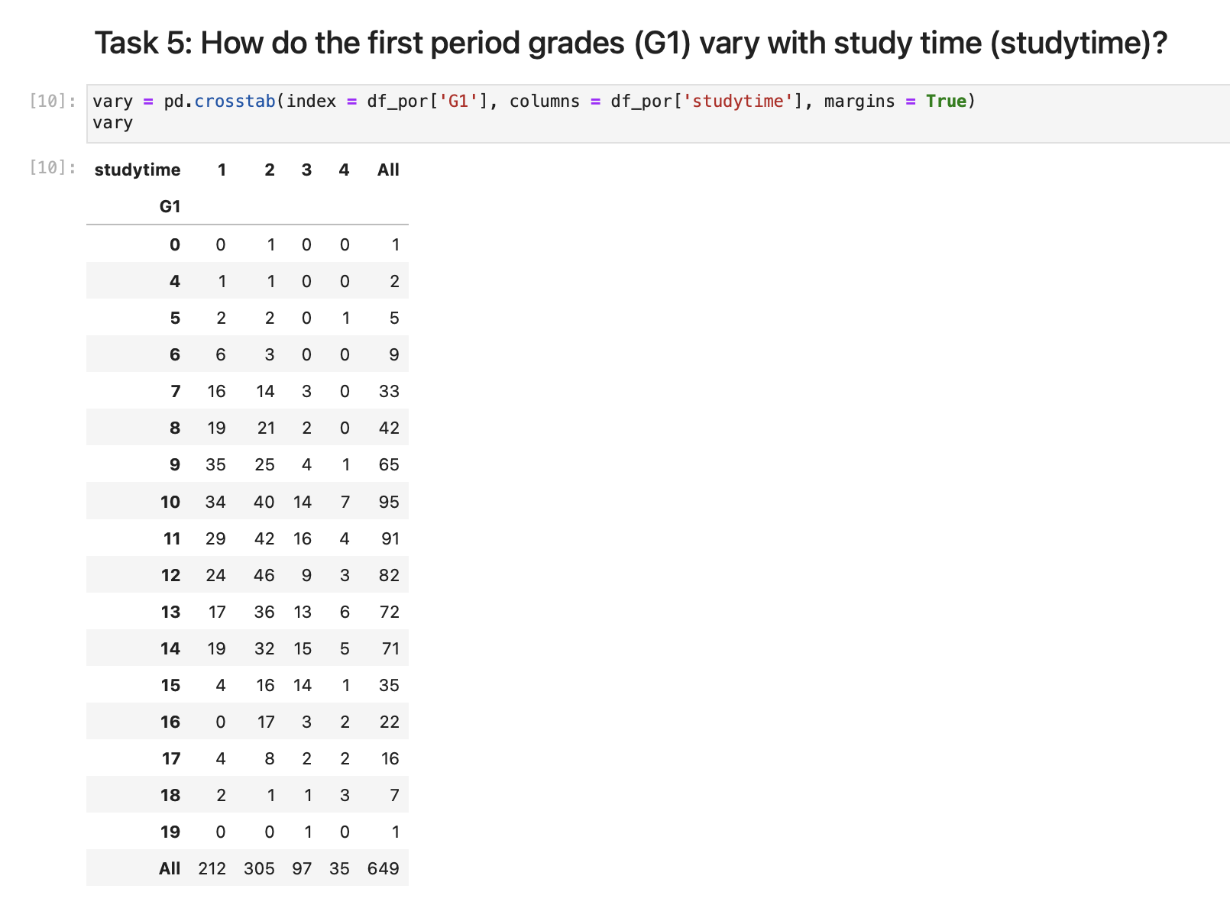

**Task 6: The correlation between the columns study time and final grades (G3) is 0.25 and we can state it is positive. Thus, if the study time increases the final grades (G3) increases too.**

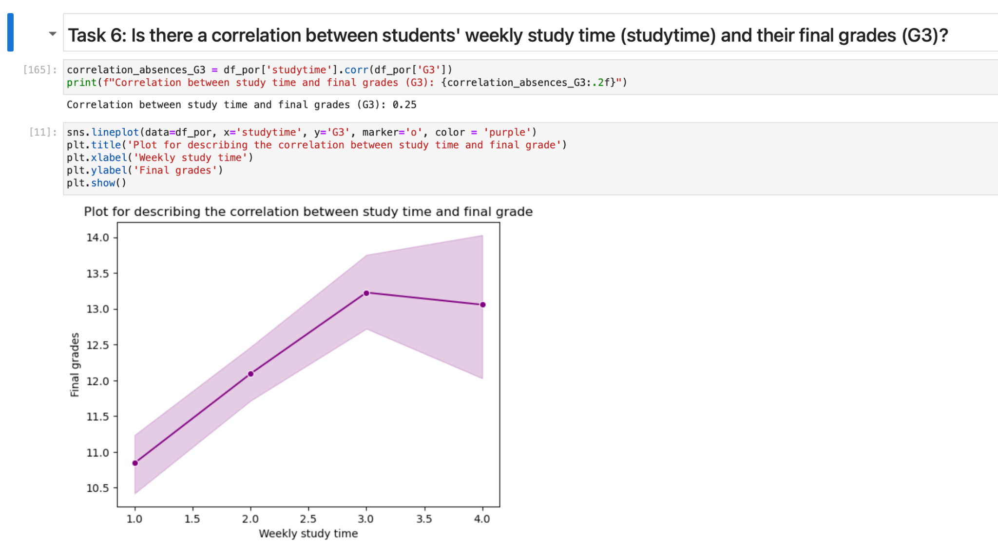

**Task 7: Majority of the students with the absences from 0-10 have the better grades.** 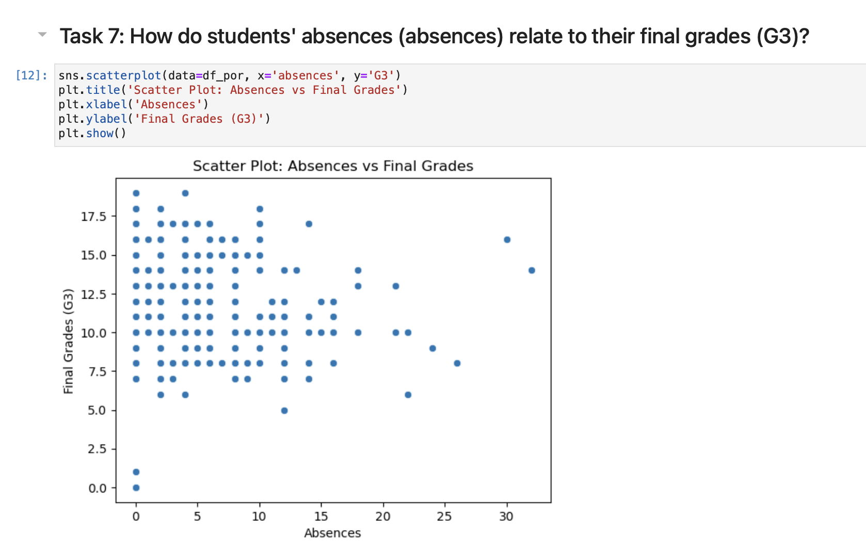

**Task 8: In this violin plot it is visible that the median of the students in urban areas is between 10-15, and the median of the students living in rural areas is a little less approximately between 10-13.**

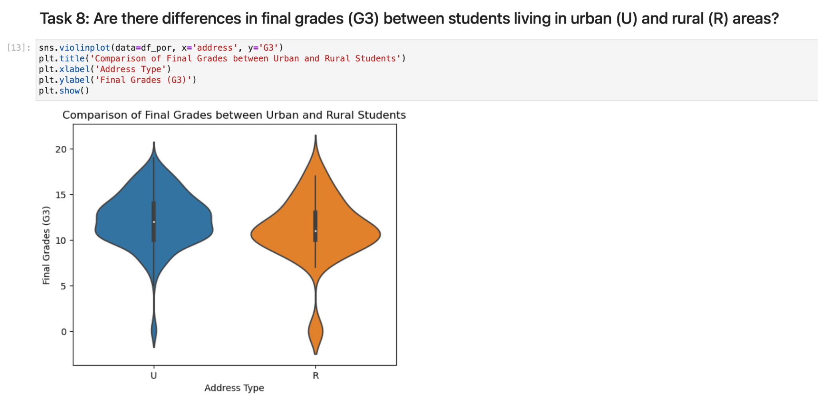

**Task 9: It is shown that both of the students with family size greater and less than 3 mostly have the relationships estimated as 4 in the rank between 1-5.** 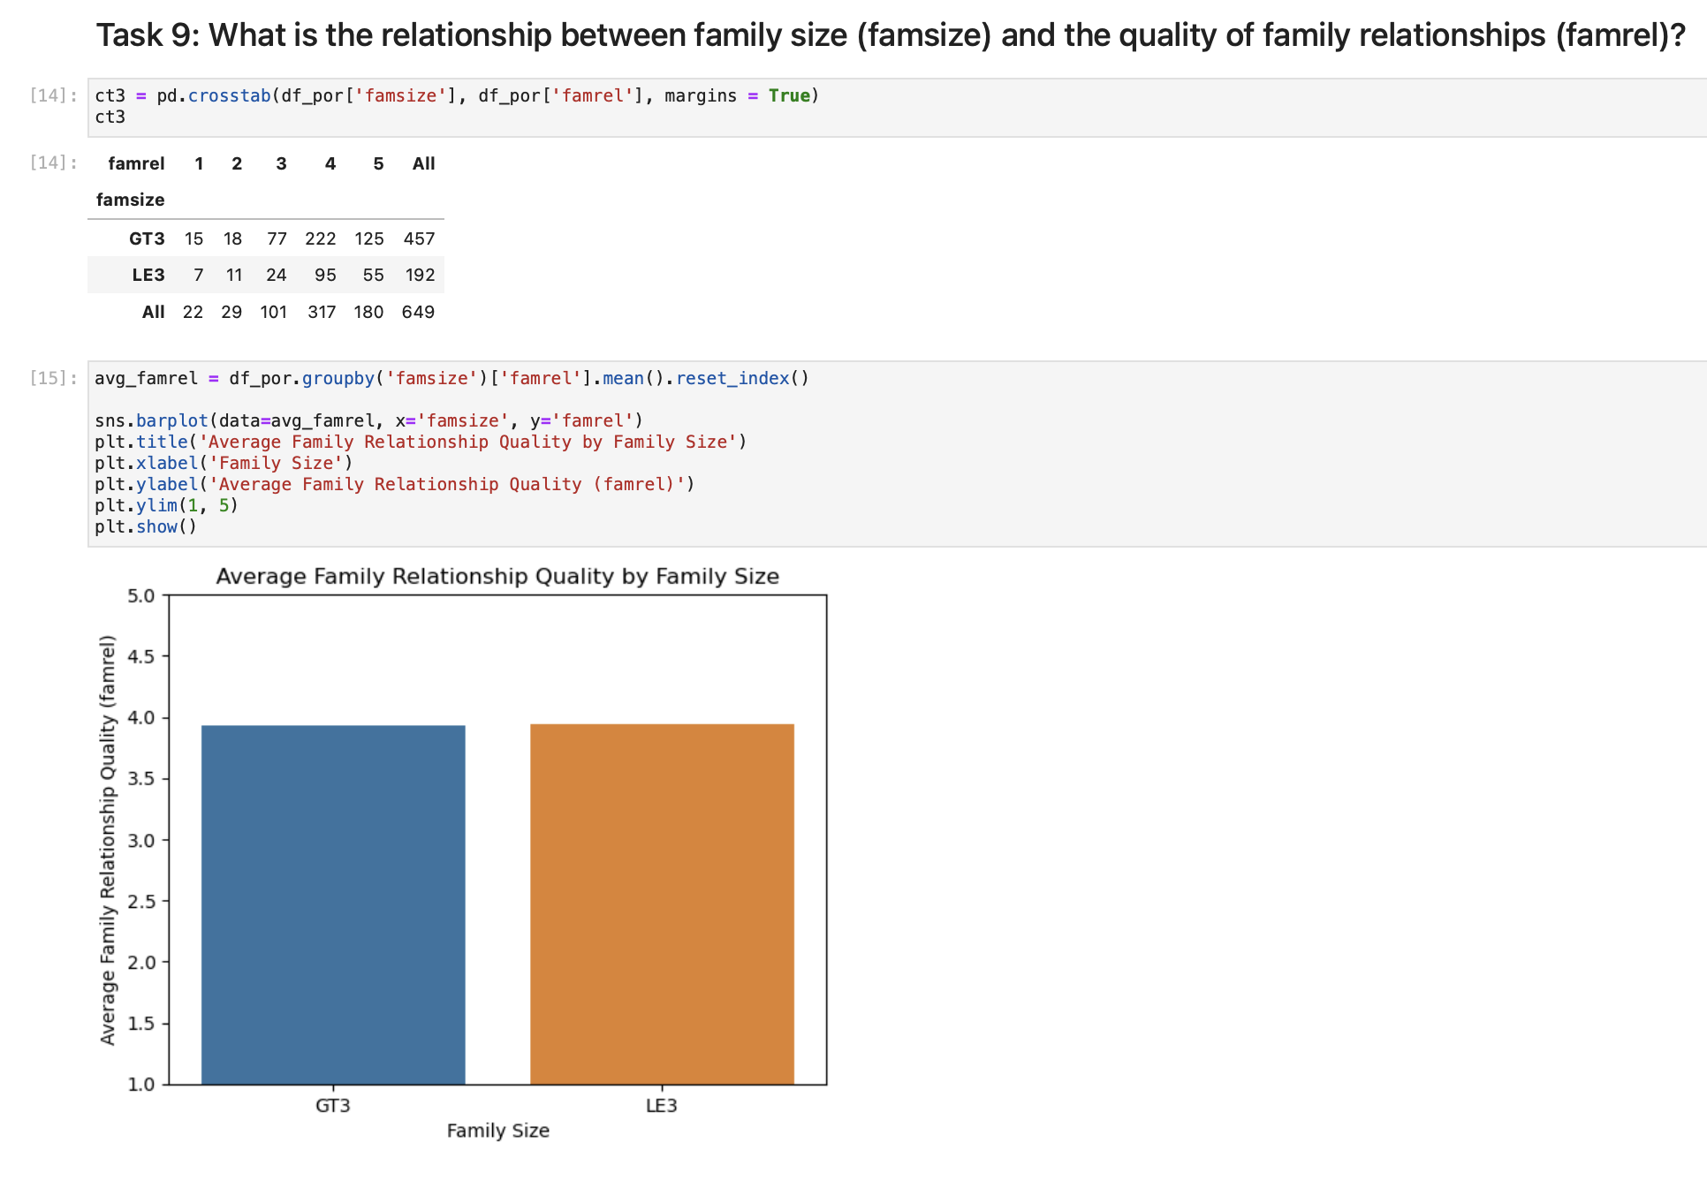

**Task 10: Daily alcohol consumption of the students who have romantic relationships is slightly higher than the students who have not romantic relationships. Otherwise, students who have no romantic relationships have slightly higher weekly consumption of alcohol.**

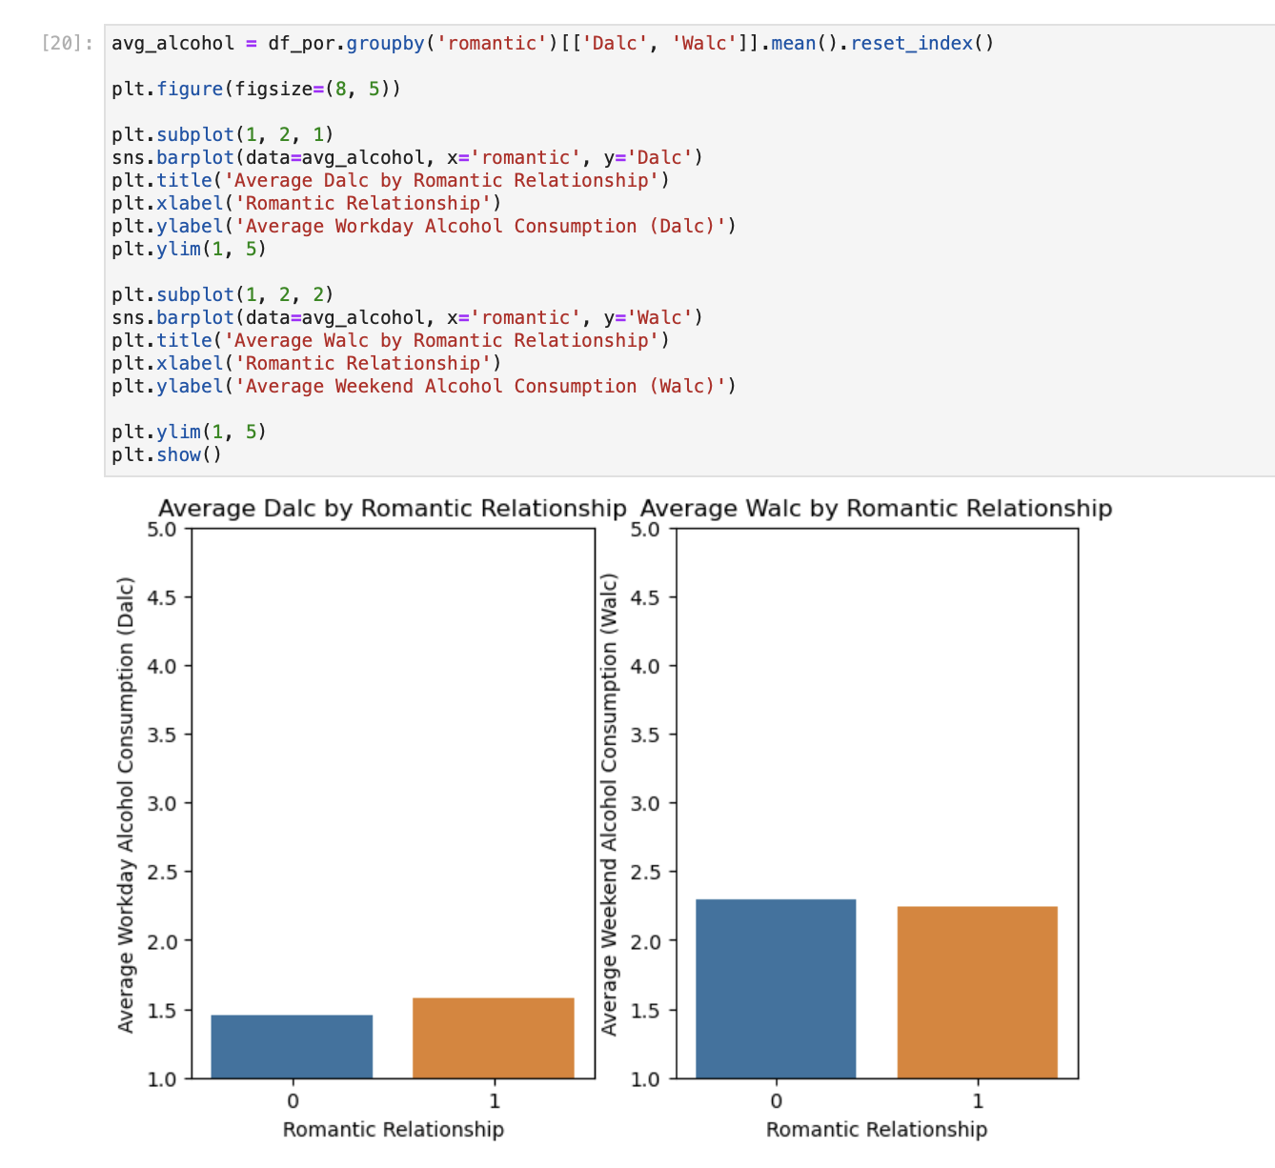

**Task 11: Correlation in percentage between mother’s education level and father’s education level is 65%.** 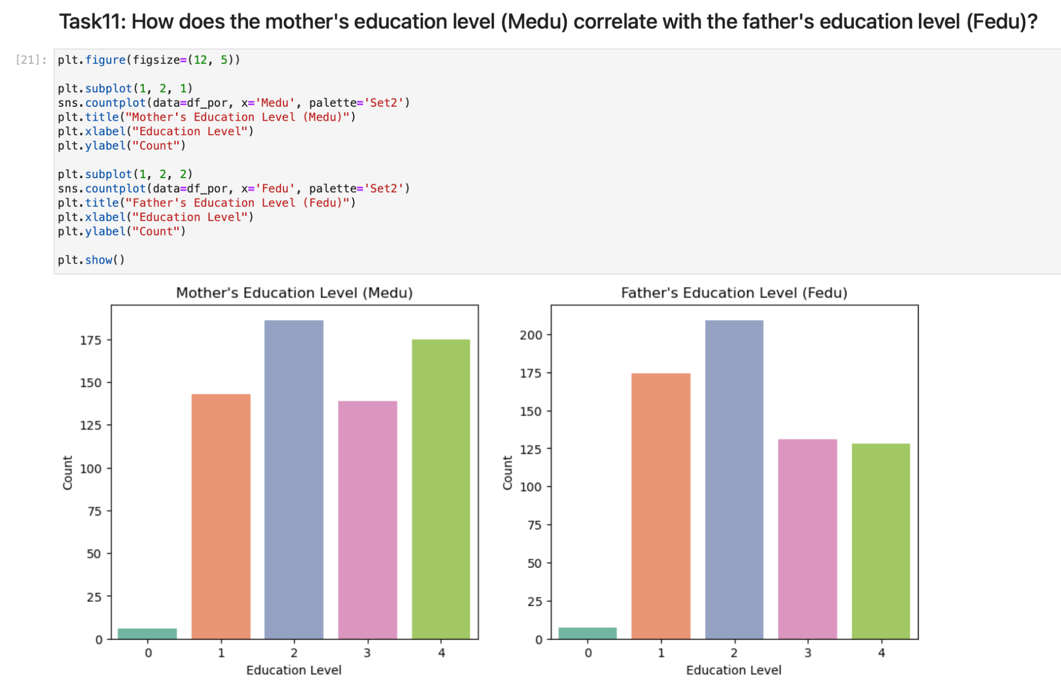

**Task 12: It is visible in both 5 number summary description and boxplot that the differences are minimal. That means that the final grades of the students do not depend on the parents’ cohabitation status.**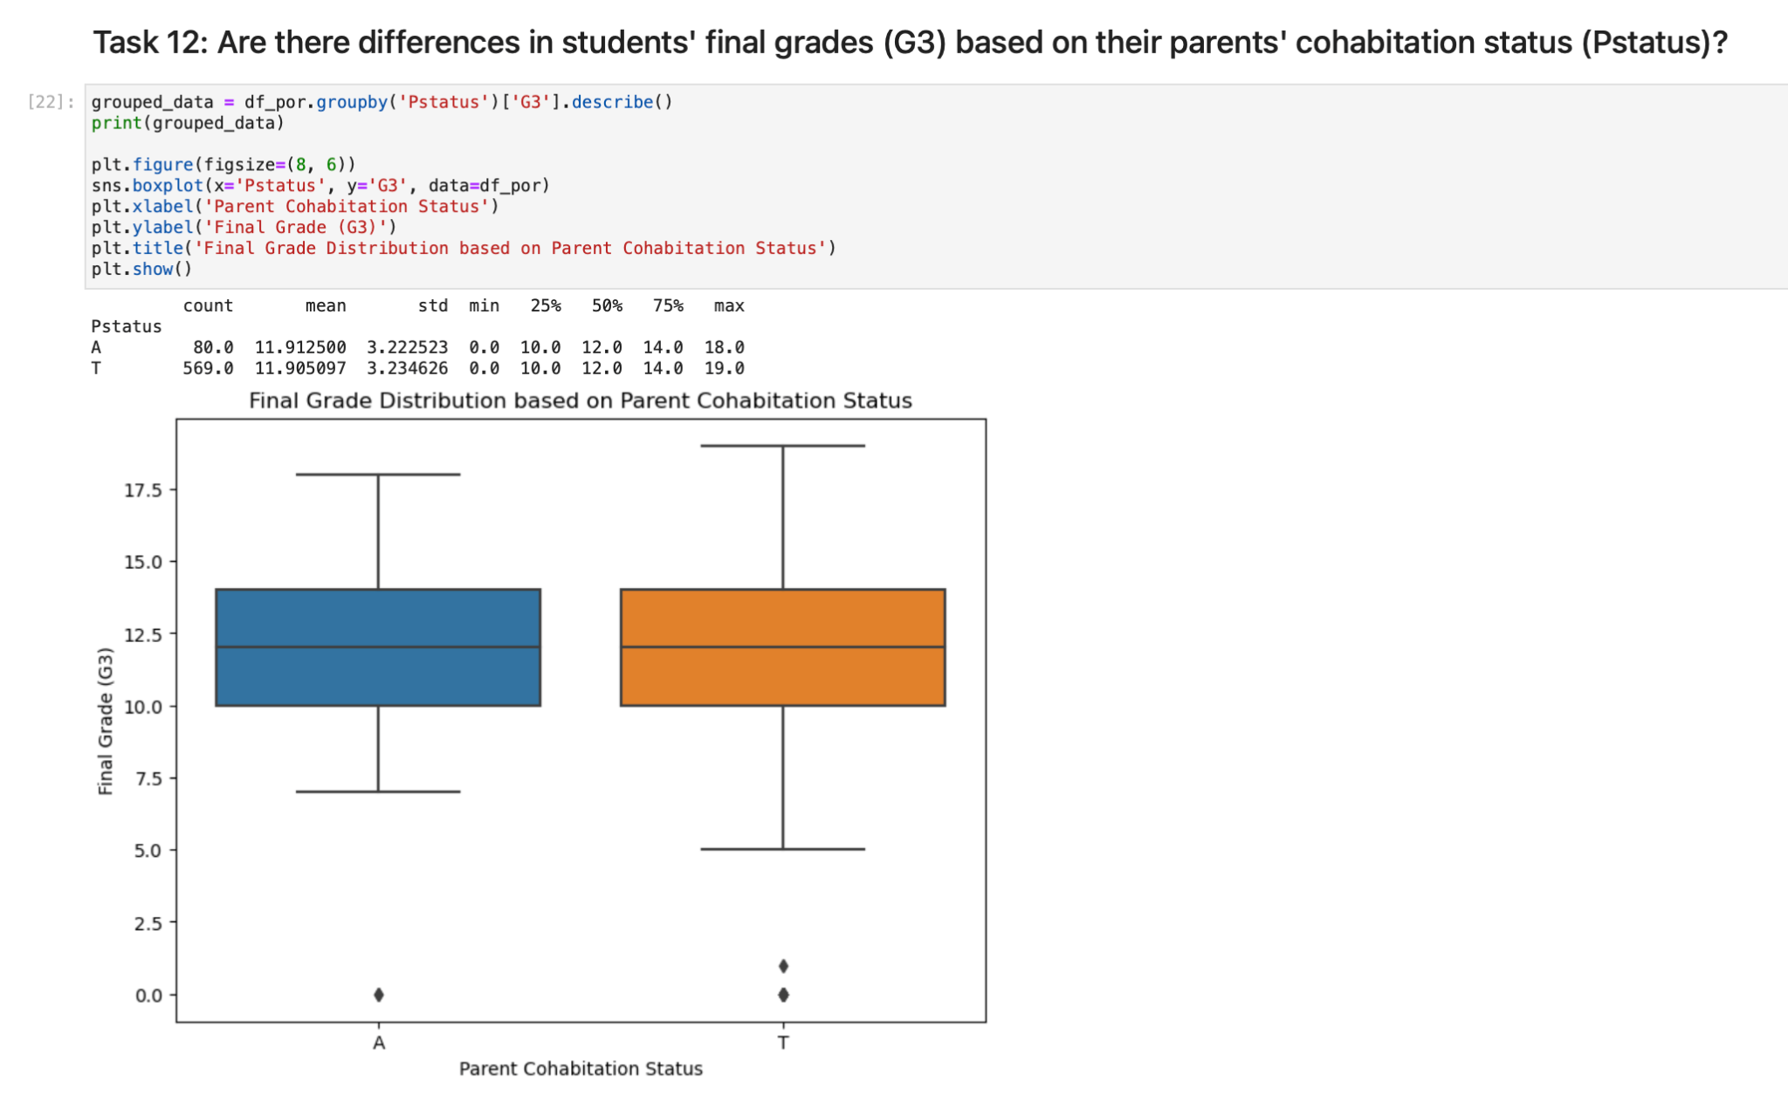

**Task 13: The most frequent final grade of the students who took Portuguese is 10.** 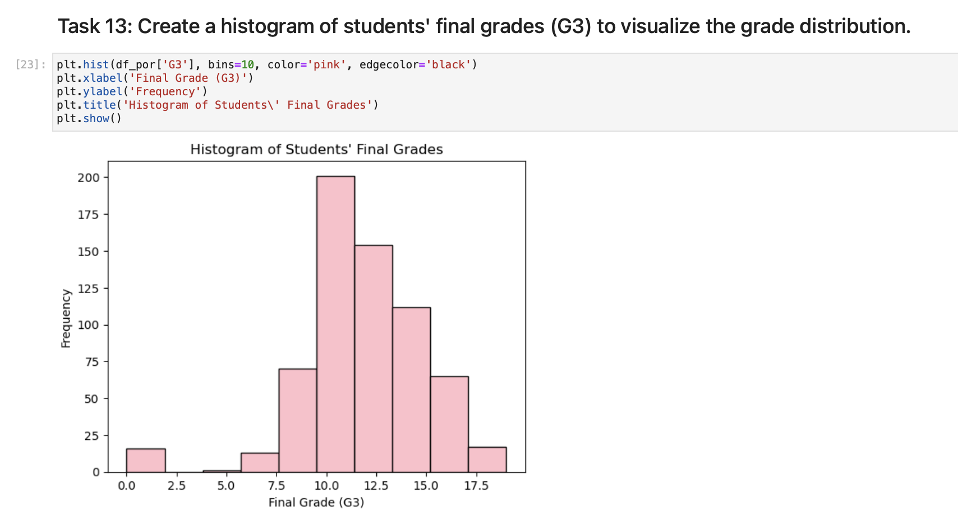

**Task 14: Scatter plot shows that highest grades belong to the students of age 18.** 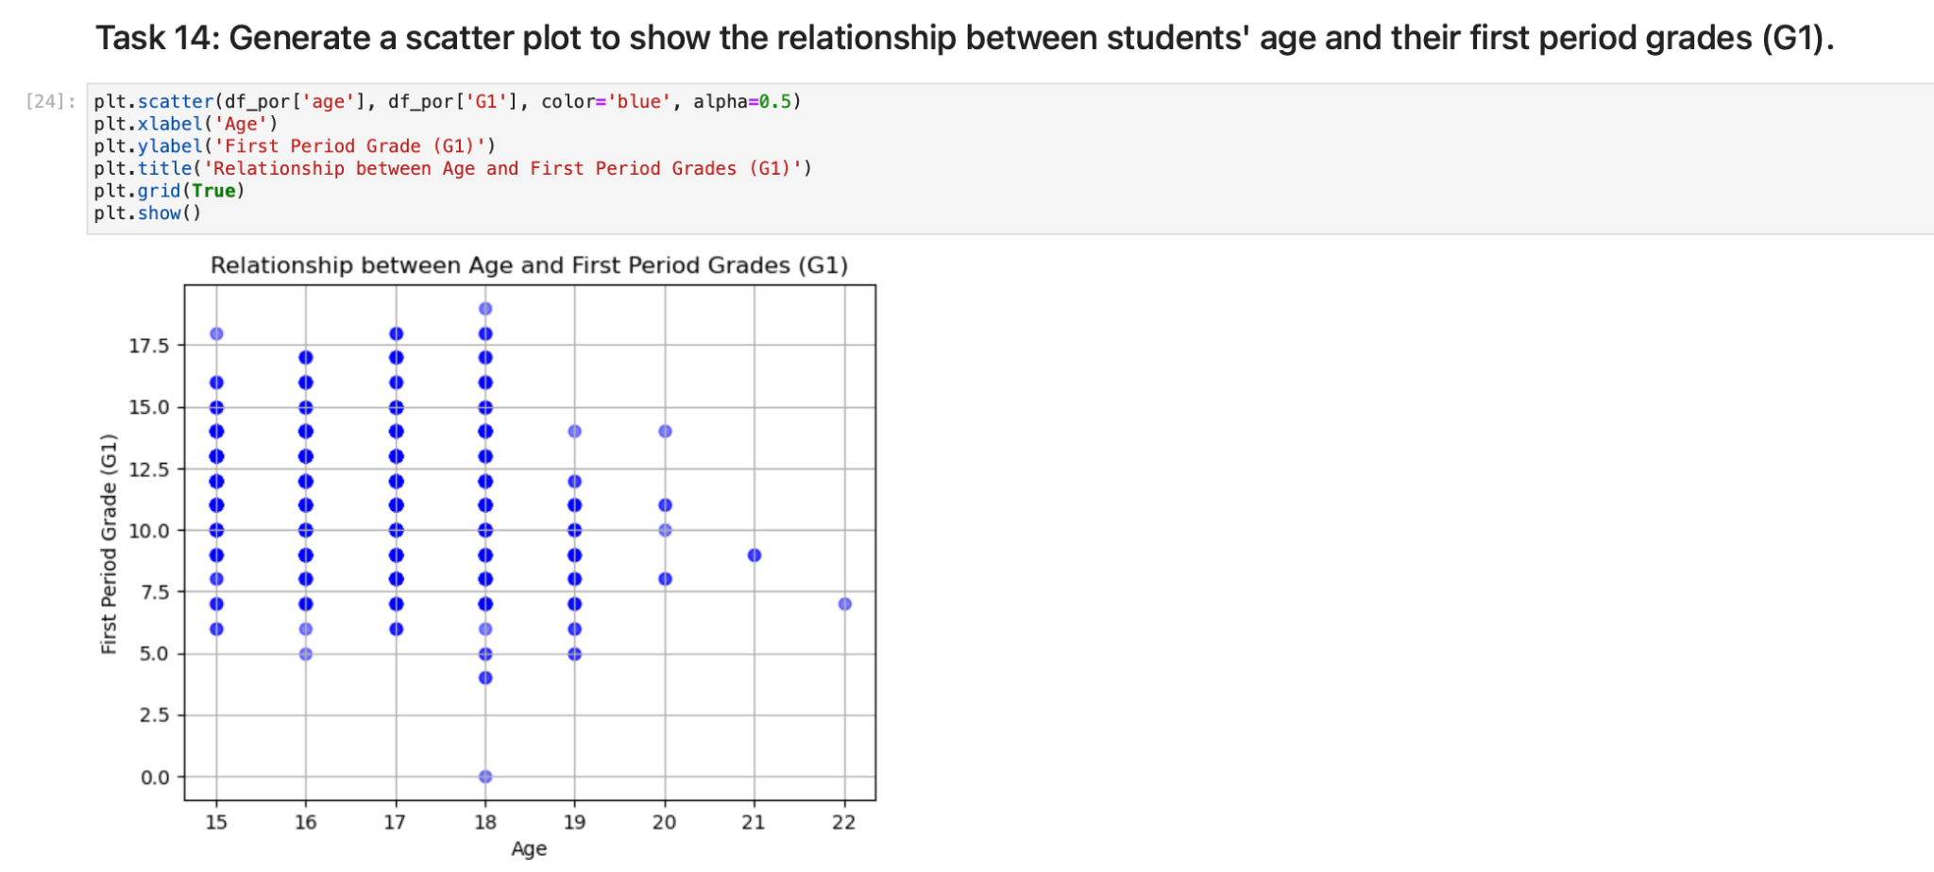

**Task 15: Average final grade of the students without educational support is higher.** 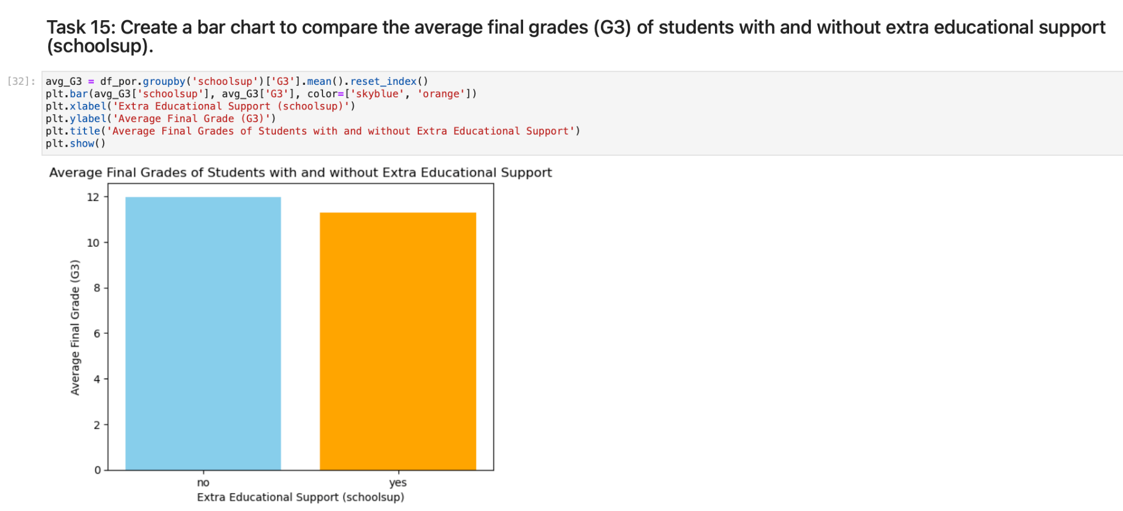

**Task 16: Average grades of the students who belong to both Math and Portuguese datasets shows that they have better performance in Portuguese classes.**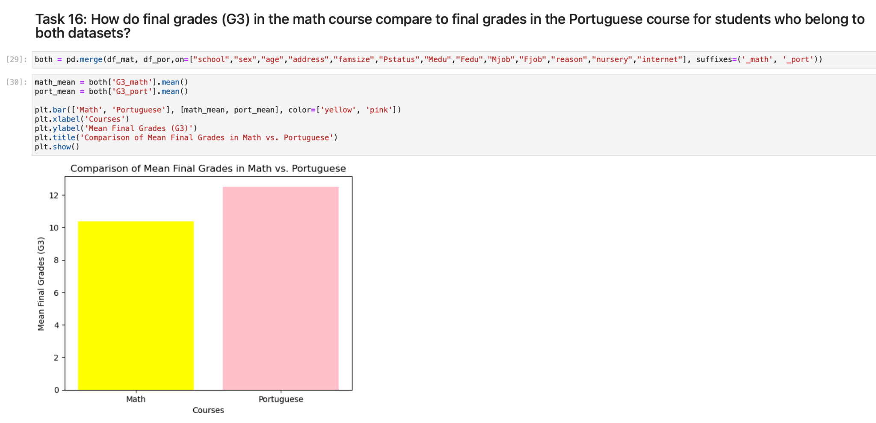

**Task 17: Distribution in both datasets is normal, however the Portuguese dataset has lower outliers. Median of the Math grades are located between 10-12.5, the median of the Portuguese grades are located higher somewhere around 12.5 and higher. Thus, that can be one more evidence to the conclusion in task16.**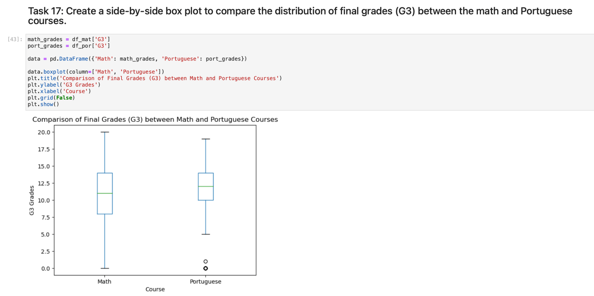

**Task 18: As it is visible in both boxplot and two-sample t-test results there is a difference in the median of the final grades of male and female students. The median grade of the male students is between 10-12,5, the median grade of female students is close to appear to be 10.** 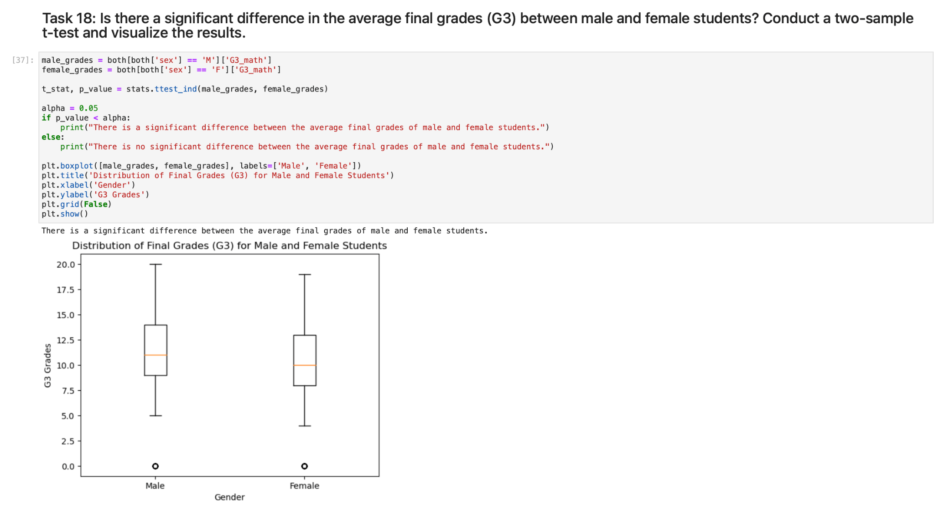

**Task 19: By categorizing students by age we can see more details about performance of students in math by their study time. It is visible that the age group between 15-17 has an average study time of 1.94 hours and their final grade is higher than other age groups. However, the age group of students between 18-20 have slightly more study time 2.12 hours, but their average final grade is 9.37.**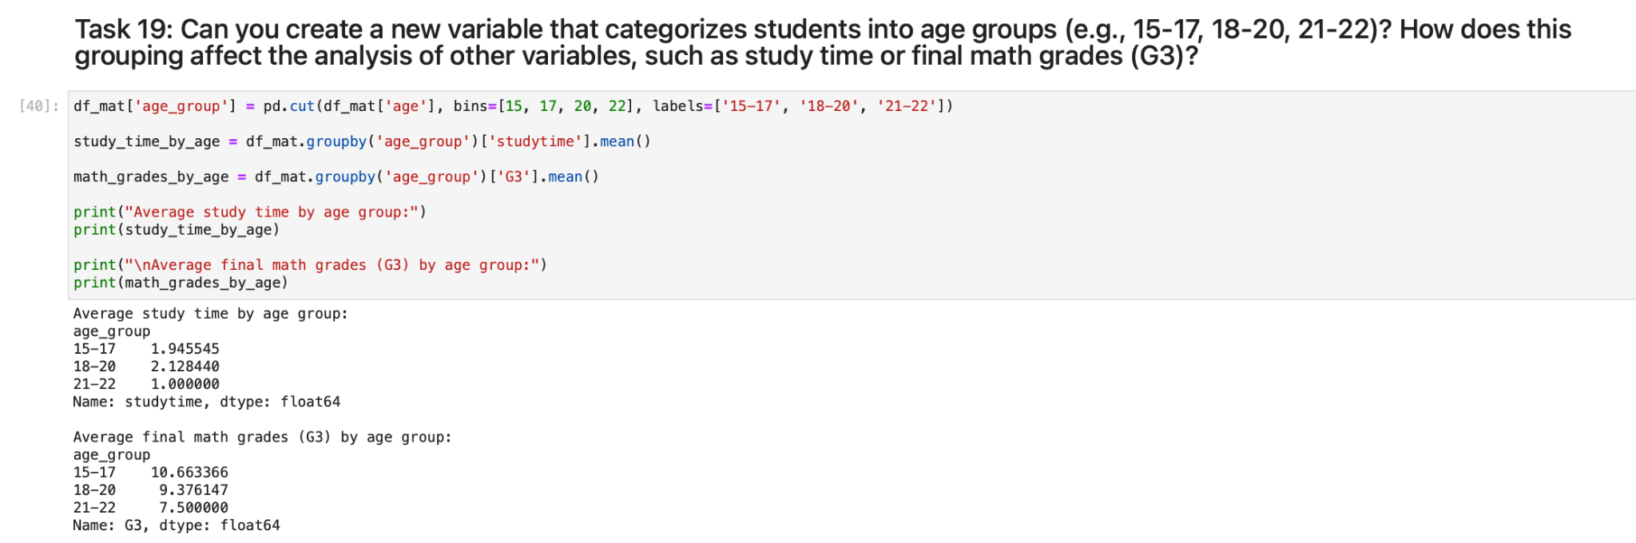

**Task 20: The left histogram represents the original distribution of school absences, showing a skewed distribution with higher frequencies concentrated toward lower absence values. The right histogram, displaying the log-transformed absences, demonstrates a more symmetric distribution, compressing higher values and spreading out lower values due to the logarithmic transformation applied to the absence data.**

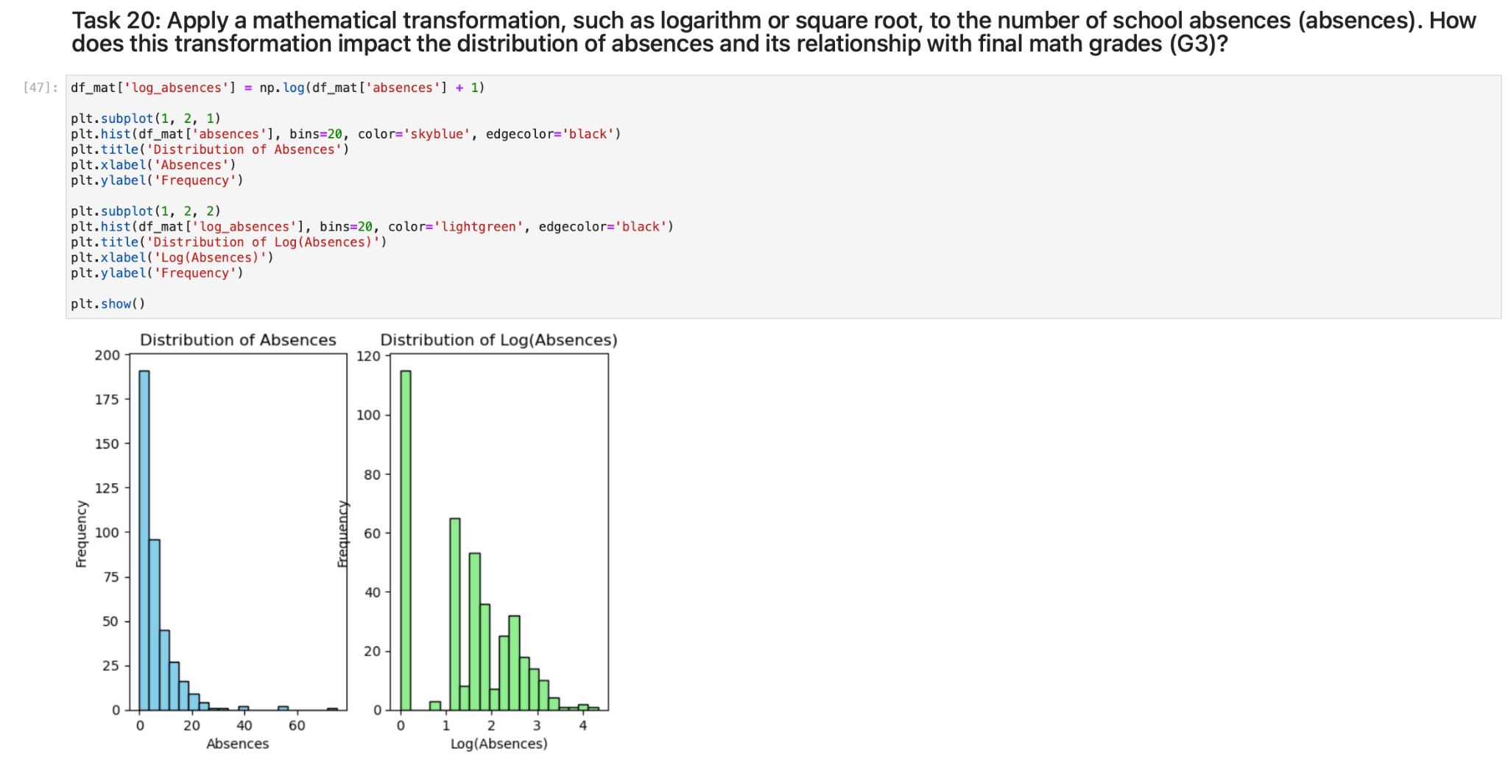

**Task 21: Students with above average study time show better performance. Their final grade is higher than the student who has below average study time.**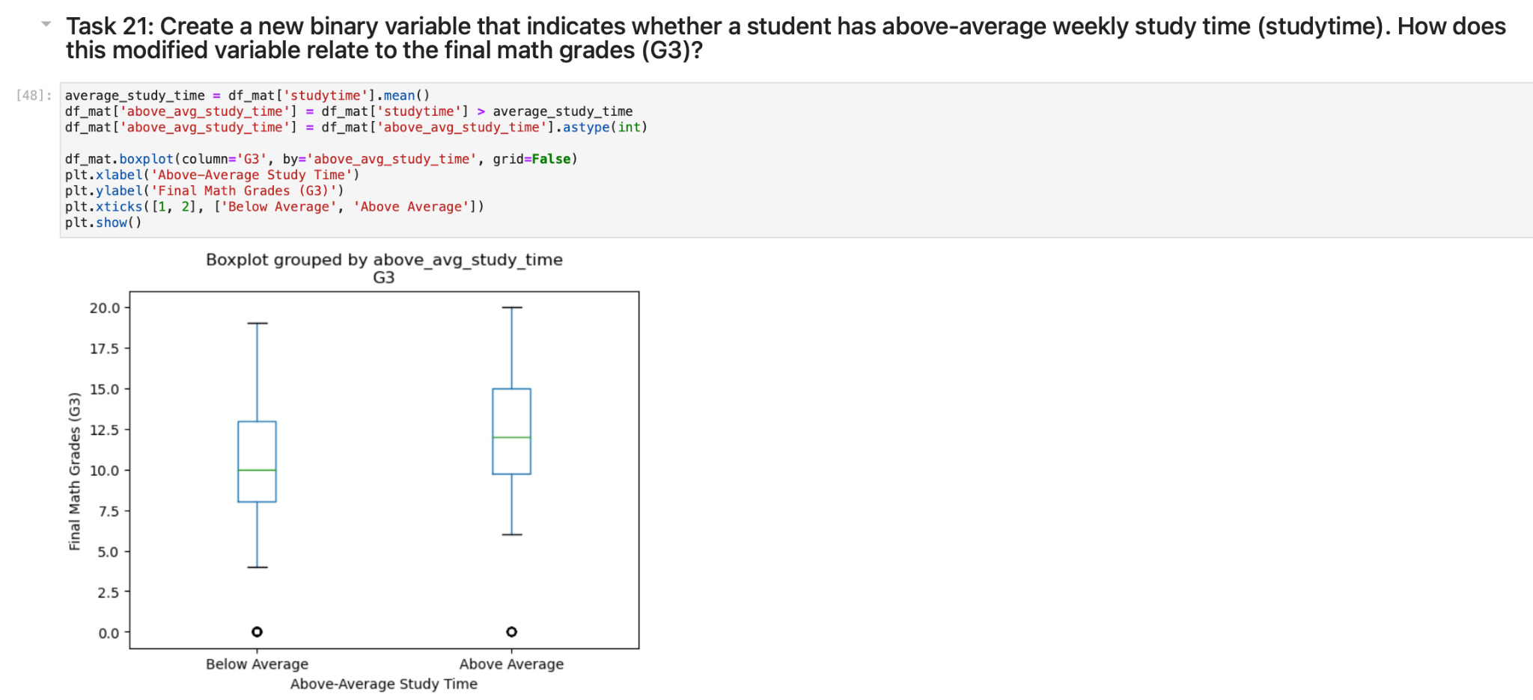

**Task 22: Min-Max scaling ensures that all features are on a similar scale, preventing the one feature from appearing frequently over other variables due to their original scale differences.**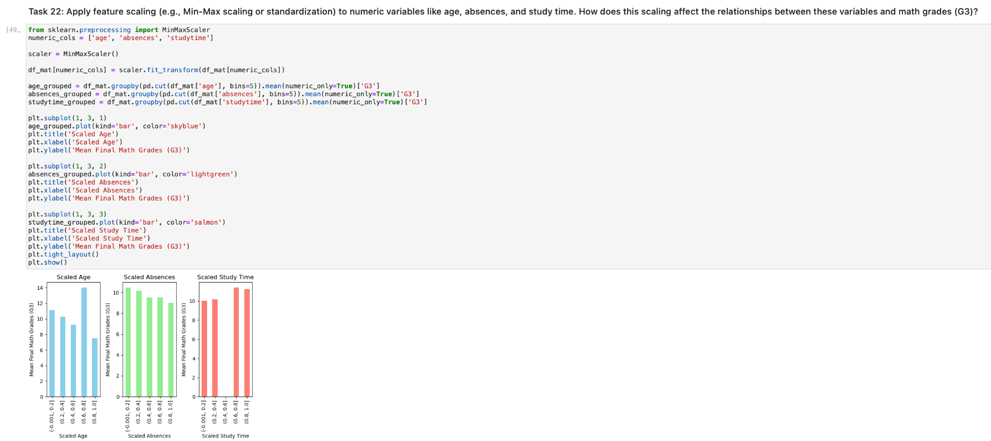

**Task 23: Transforming categorical variables using label encoding or one-hot encoding increases the data's appropriateness for study. One-hot encoding, in particular, helps to preserve category independence and can give more precise insights into data relationships.**

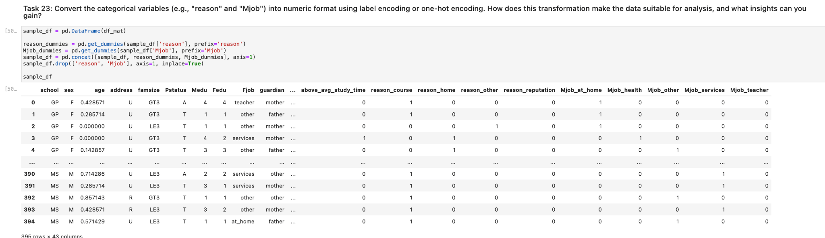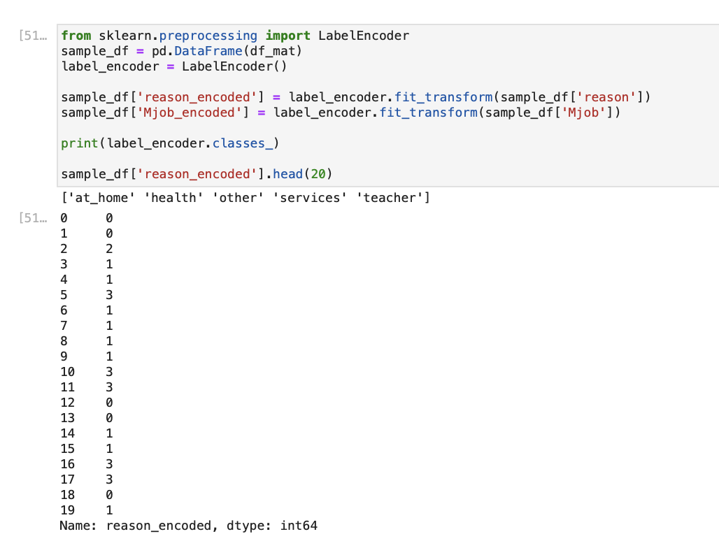

**Task 24: Correlation between parents’ education level is 20%. A 20% correlation between parental education levels indicates a weak positive linear association between parental education levels.**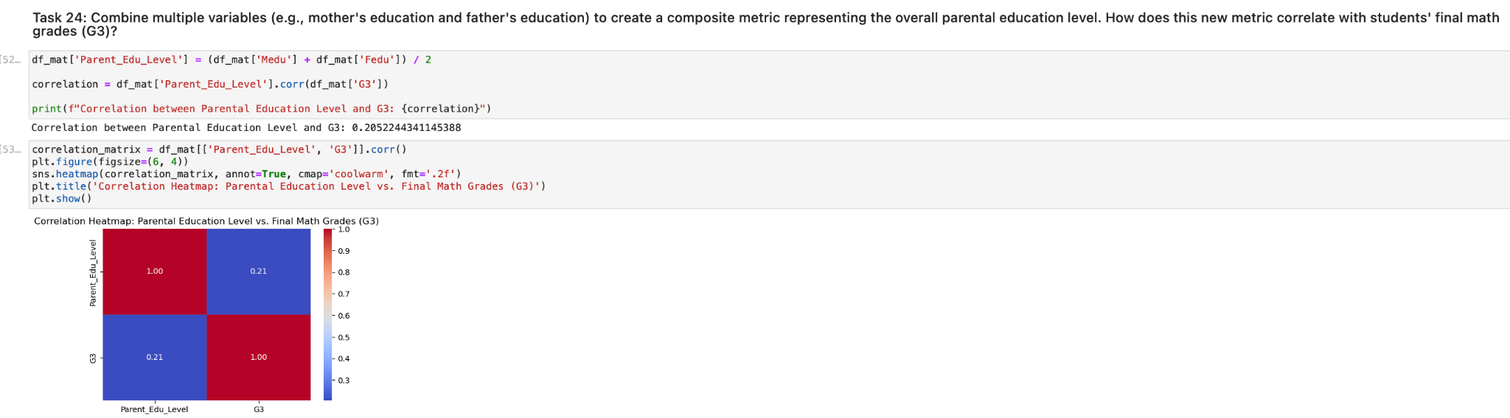

**Task 25: Average study time of the students living in rural areas are slightly higher than the study time of the students living in urban areas.**

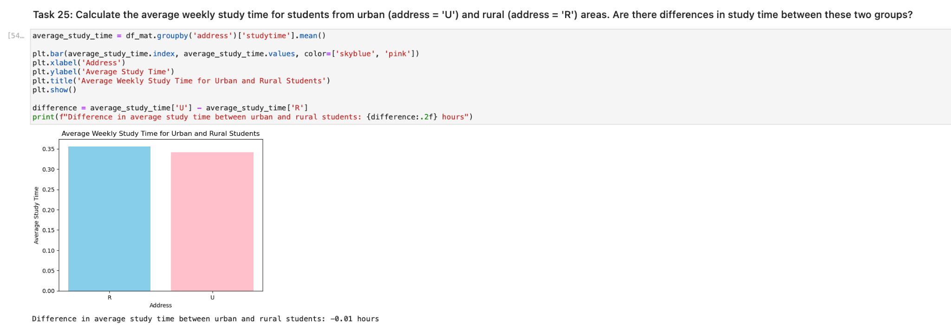

**Task 26: Using this reverse mapping, the labels are mapped backwards to their corresponding number values, and the resulting numerical values are used to replace the labels in the 'famrel' column. The words "good," "excellent," "neutral," etc. should be replaced by numerical values ranging from 1 to 5 in the "famrel" column following the execution of this code.**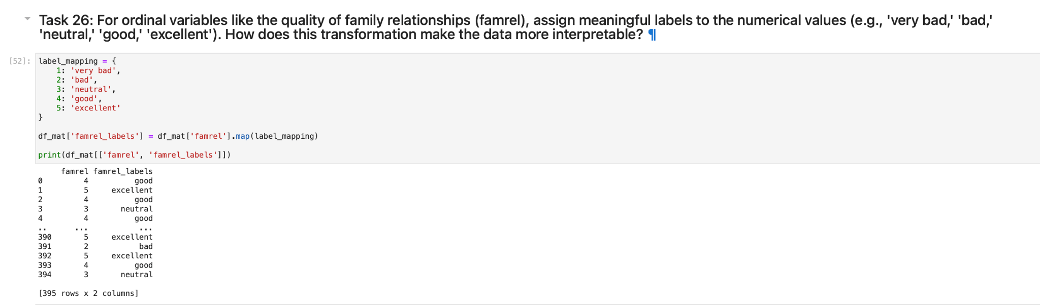

**Task 27: The internet access percentage is 74.4% for females and 80% for males. GP school age range is 7, for MS school it is 5.**

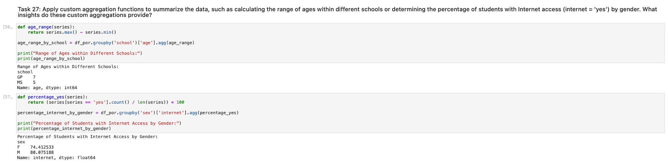

**Task 28: No need to apply date-related functions to variables, such as determining the day of the week for which students have the most absences.**

**Task 29: Median number of school absences is 2 for both with and without educational support.**

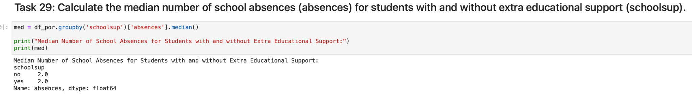

**Task 30: It can be assumed that the students with 0 level of higher education want to take higher education level for 100%. Also, the students with least willingness to take higher education are with a father's education level of “1” (81%).**

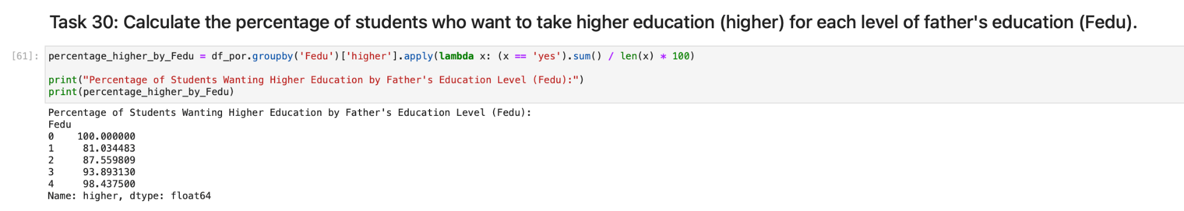

**Task 31: Correlation between travel time and final grades is -0.12, which means that it is negatively correlated.**

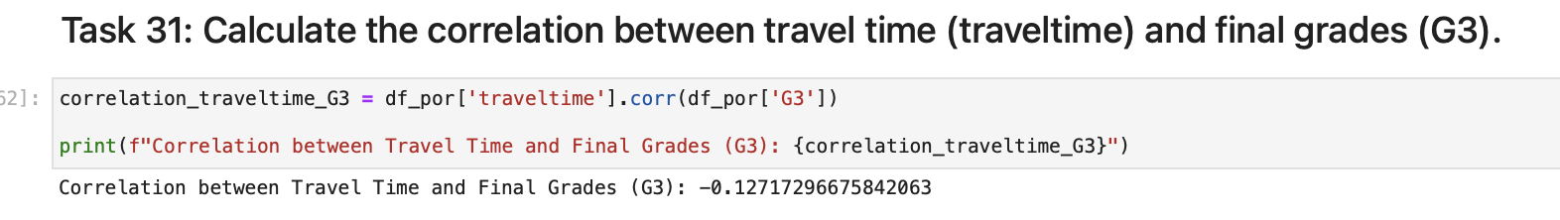

**Task 32: The weighted average of final grades, which is 12.25, indicates that the overall average of final grades is 12.25 when study time is taken into account when determining weights. Final grades correspond to higher time spent studying.**

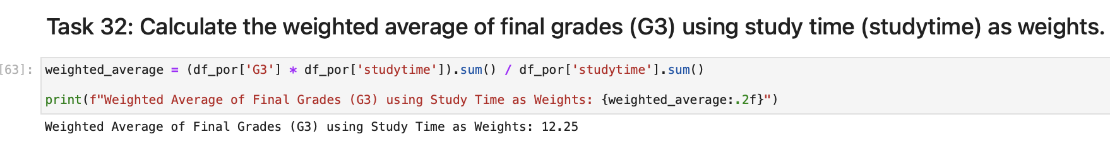

**Task 33: Output shows that there are 5 students whose weekend alcohol consumption is the highest among other students (5).**

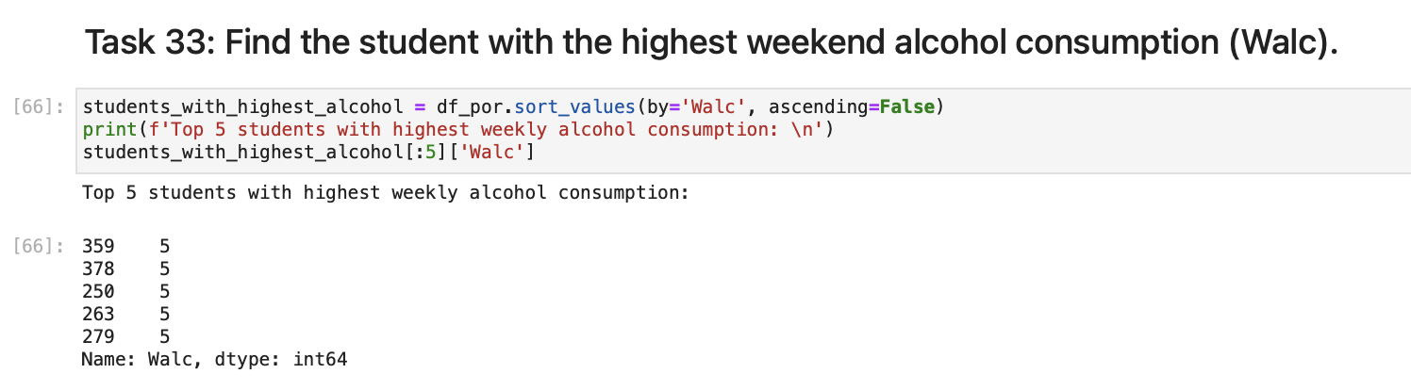

**Task 34: There were no missing values before replacing.**

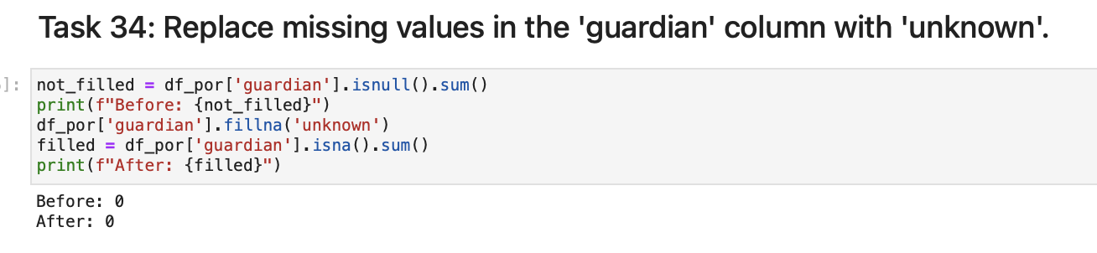

**Task 35: Filled.**

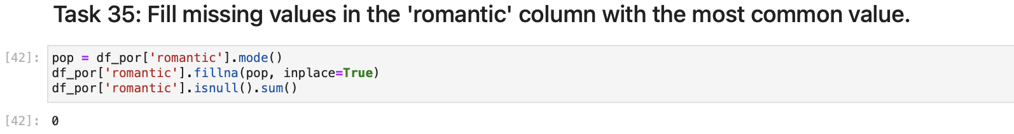

**Task 36: Maximum for all of the reasons for choosing the school is 4, and the minimum is 1.**

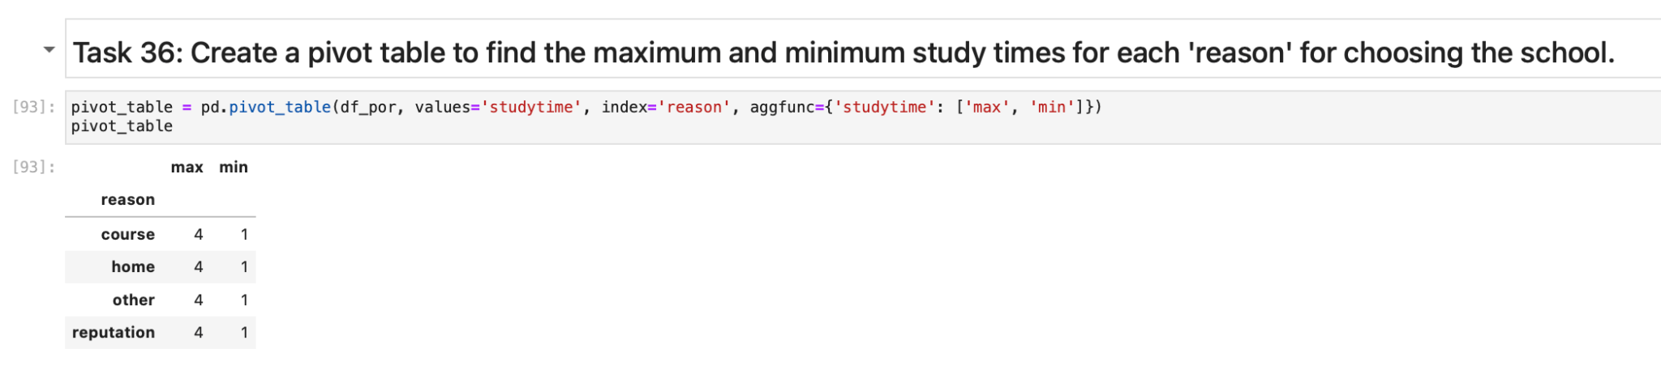

**Task 37: There are 16 students in the dataset having both parents’ jobs as teachers.**

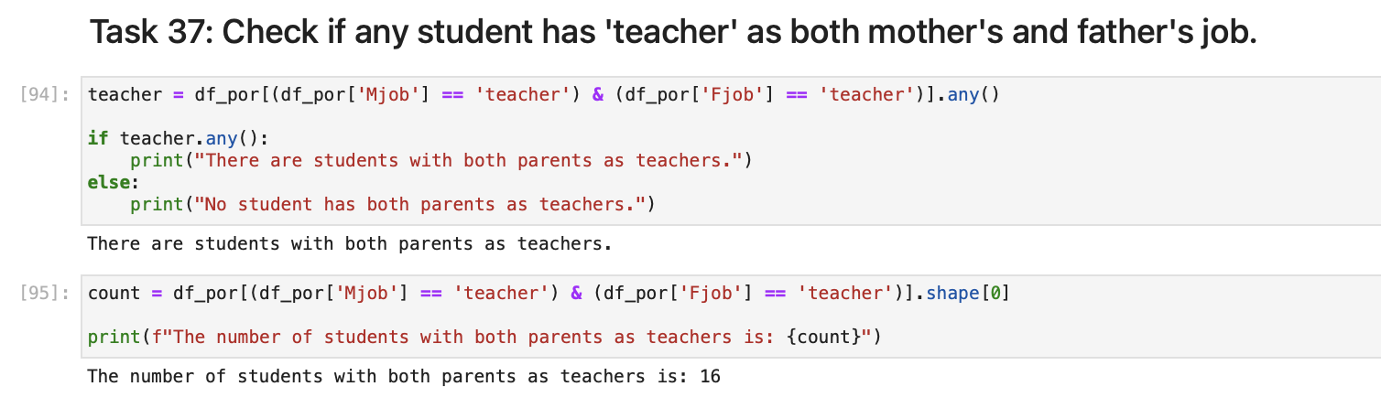

**Task 38: The at_home option is replaced with homemaker and also the count of mother’s and father’s jobs separately is 135 for mother’s job and 42 for father’s job.**

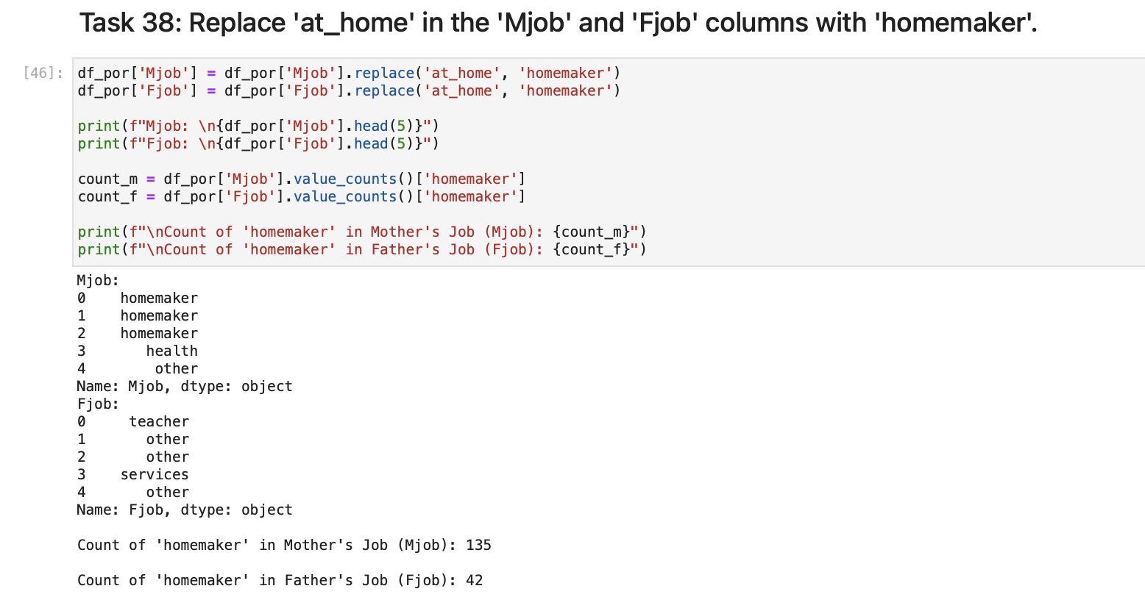

**Task 39: The columns Mjob and Fjob now appear to be 1 column named Parentjob.**

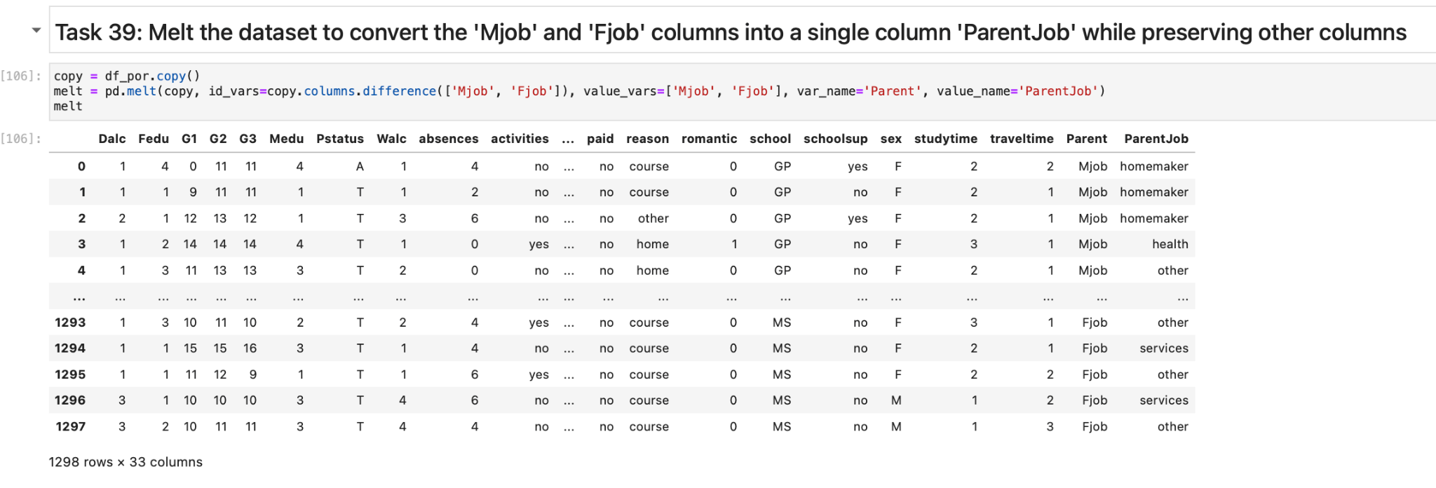

**Task 40: Now the grades of students in a scale from 0-16 is a letter grade. A is the highest and F is the lowest.**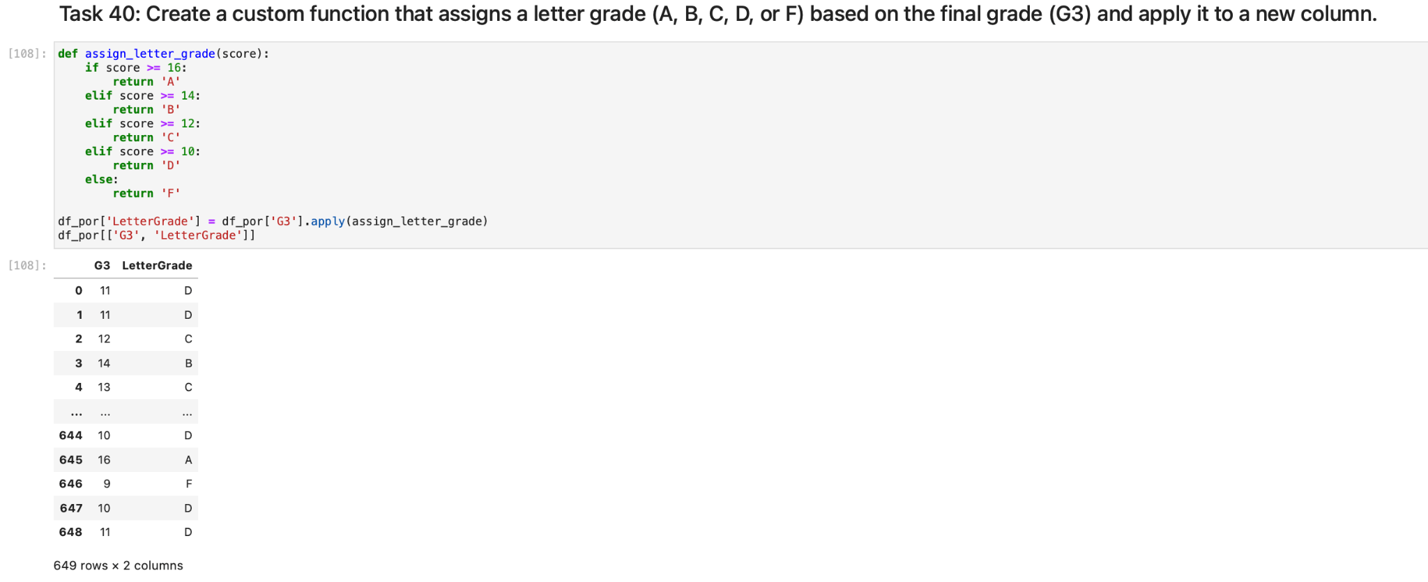

**Task 41: No need to create a time series plot showing the trend in weekly study time (studytime) over time for a specific student.**

**Task 42: Merged two datasets into one named merged_df.**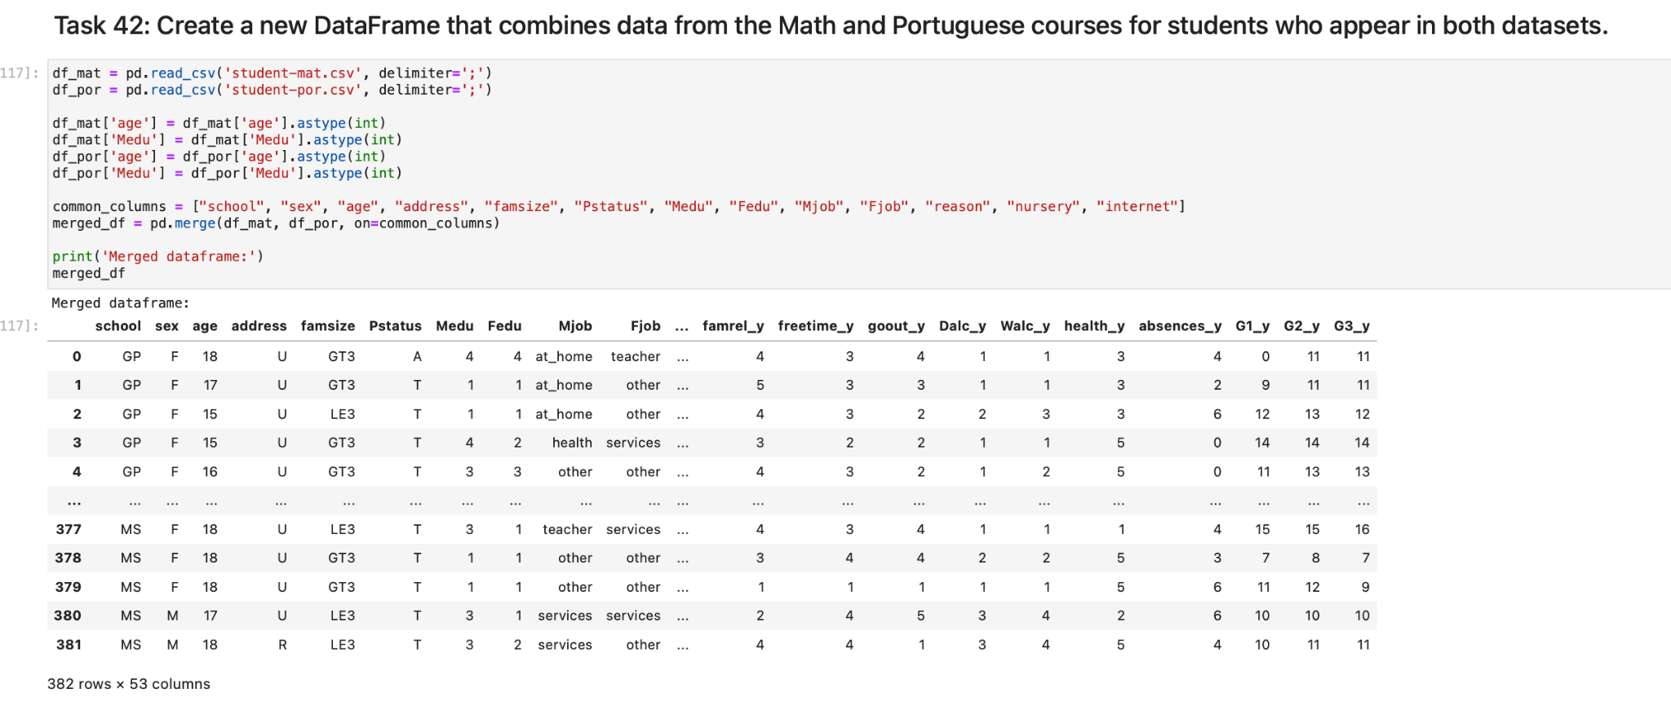

**Task 43: The top final grade is 20 and belongs to the student of ID 47.**

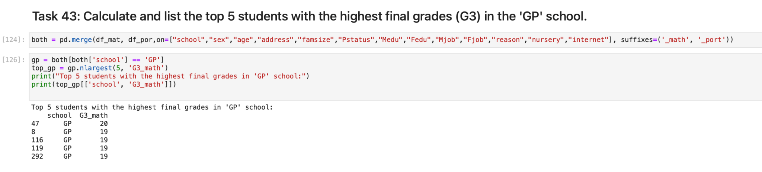

**Task 44: The travel time mostly appears to be 2 hours for the students of MS school.**

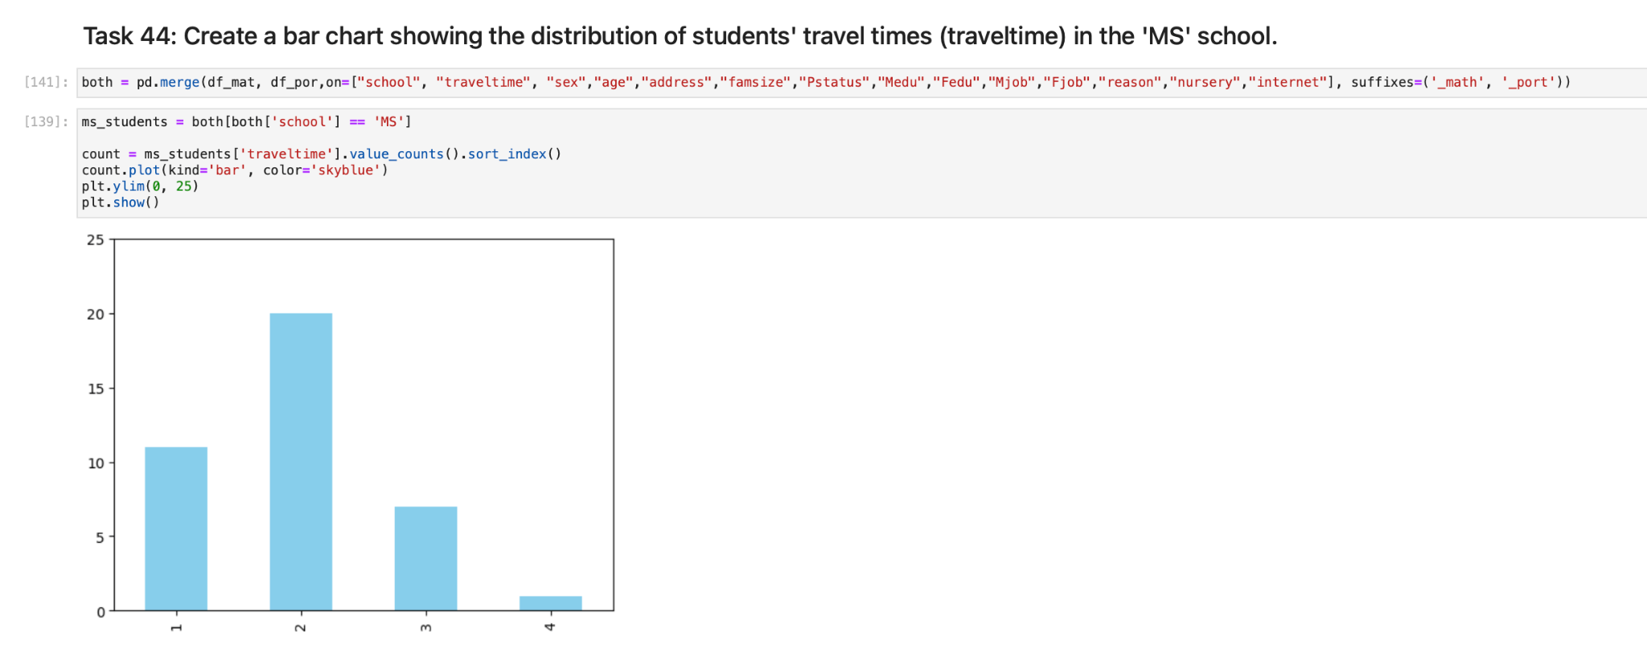

**Task 45: The mean age of students who have extra-curricular activities is 16.49 and for the students without is 16.67.**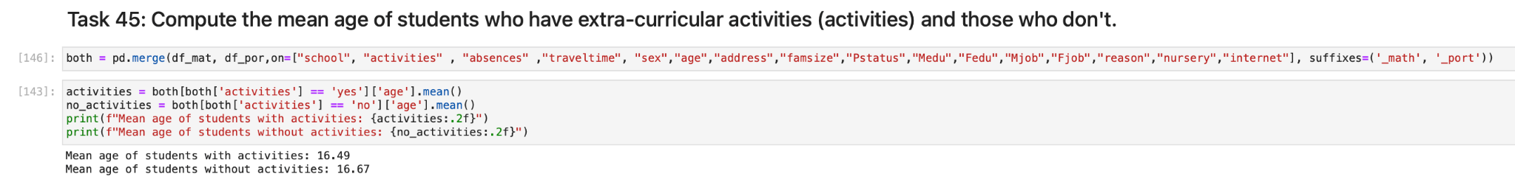

**Task 46: For the female students living in rural areas the median number of absences is 2, for the female students living in urban areas the median number of absences is 0. For the male students living in rural areas the median number of absences is 2.5, for the male students living in urban areas the median number of absences is 0. Students living in urban areas are less likely to skip classes.**

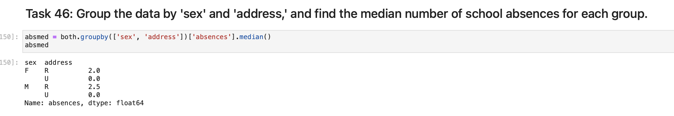

**Task 47: Students’ percentage of receiving extra educational support is 86,76% and the same percentage is for the students without extra education support.**

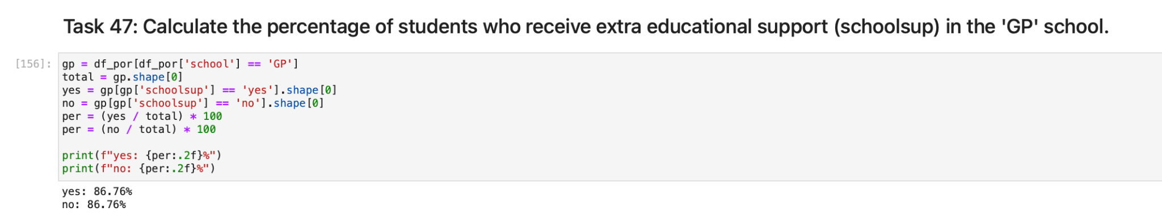

**Task 48: X-label for G1 and Y-label for G3.**

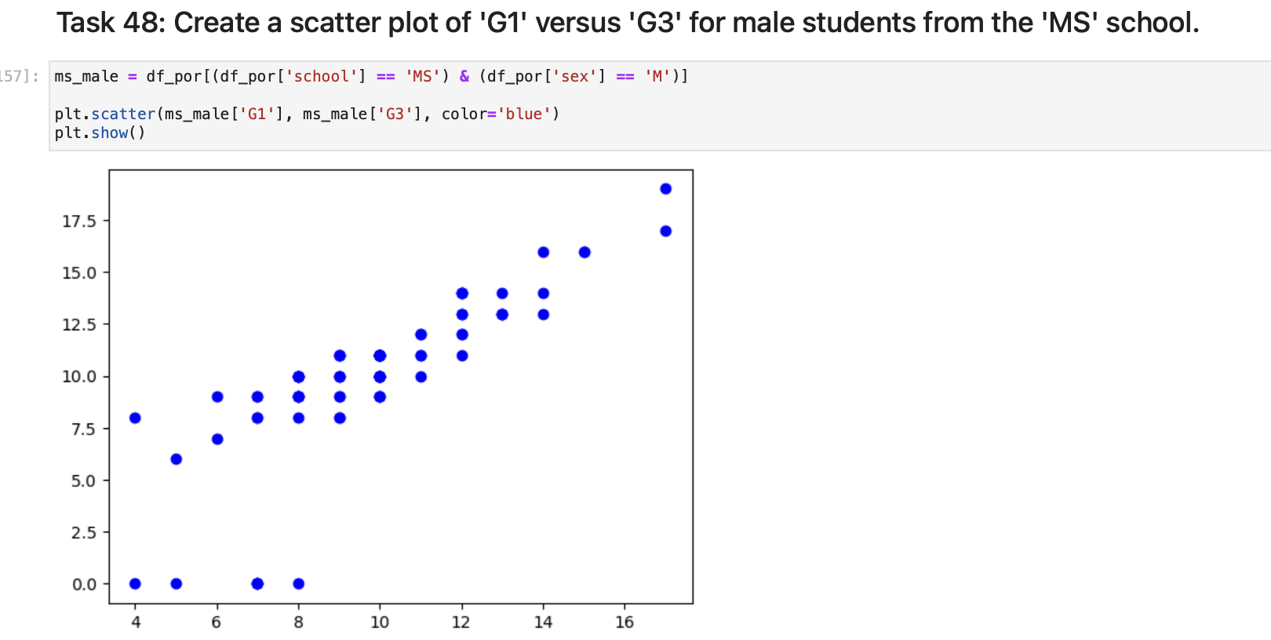

**Task 49: There is 1 student with ID 588 with a unique combination of parents’ job.**

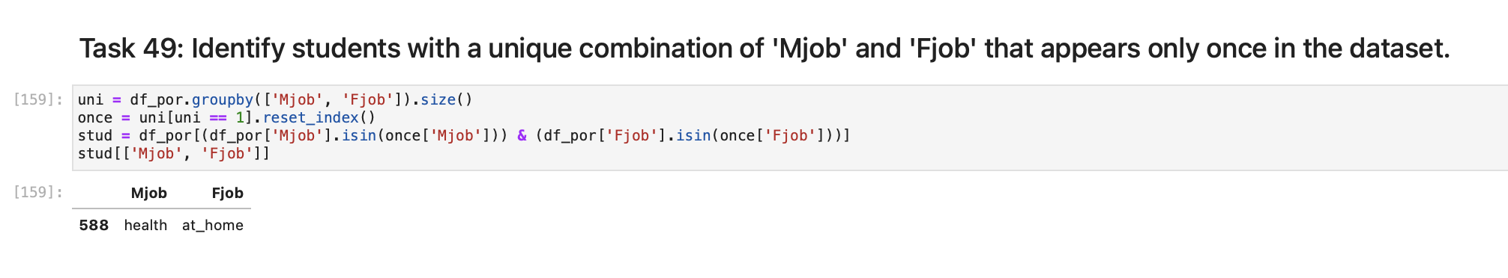

**Task 50: In GP school the highest final grade with respect to the study time is 13.56, study time is 3 hours. In MS school the highest final grade with respect to the study time is 12.07, study time is 3 hours.**

